**Programming Fundamentals**

**Lab # 1**

**Exercise 1**

**Code:**

|  |
| --- |
| **public** **class** Hello {  **public** **static** **void** main(String[] args) {  System.***out***.println("Hello World");  }  } |

**Step by Step Explanation:**

1. Change Lab1Ex1 to Hello

When I changed the Lab1Ex1 to Hello it gives Error.



It means class name cannot be changed. Class name and .java file name must be same.

1. Remove the first quotation mark in the String

When I removed the first quotation mark in the sting it gives the Syntax error.

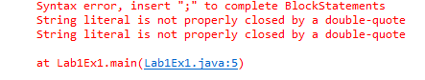

It means String should be enclosed by double-quote.

1. Remove the semicolon

By removing the semicolon, it gives the Syntax error again.

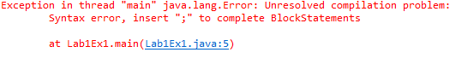

1. Remove the last brace in the program

By removing the brace again, it gives the Syntax error.

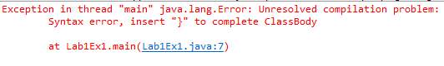

**Exercise 2**

**Code:**

|  |
| --- |
| **public** **class** GradeAvg {  **public** **static** **void** main(String[] args) {    **double** quizScore1 = 40;  **double** quizScore2 = 45;  **double** quizScore3 = 50;  **double** testScore1 = 70;  **double** testScore2 = 80;  **double** quizScoreAvg = 0;  **double** testScoreAvg = 0;    quizScoreAvg = (quizScore1 + quizScore2 + quizScore3)/3; // Expression Calculates the Average of Quiz score    testScoreAvg = (testScore1 + testScore2)/2; //Expression Calculates the Average of Test Scores    System.***out***.println("Average Quiz Score is :" +quizScoreAvg); // Display Average Quiz Score    System.***out***.println("Average Test Score is :" +testScoreAvg); // Display Average Test Score  }  } |

**Output:**

|  |
| --- |
|  |

**Exercise 3:**

**Code:**

|  |
| --- |
| **import** java.util.Scanner;  **public** **class** AgeGuess {  **public** **static** **void** main(String[] args) {  String name;  **int** ageGuess;    Scanner input = **new** Scanner(System.***in***); //New Scanner Object input is declared    System.***out***.print("Please Enter the name: ");  name = input.nextLine(); //Reads the name from Keyboard    System.***out***.print("Please Enter the age: ");  ageGuess = input.nextInt();//Reads the age from Keyboard    System.***out***.println("Name is " +name);//Display the name    System.***out***.println("Age is " +ageGuess);//Display the age Guess  }  } |

**Output:**

|  |
| --- |
|  |

**Exercise 4:**

**Code:**

|  |
| --- |
| **import** java.util.Scanner;  **public** **class** TimeComp {  **public** **static** **void** main(String[] args) {  **int** inputSeconds;  **int** hours;  **int** minutes;  **int** seconds;    Scanner input = **new** Scanner(System.***in***);//New Scanner object input is declared    System.***out***.print("Please Enter the Time in Seconds: ");  inputSeconds = input.nextInt();//Reads the Time in Seconds from Keyboard    //Calculating the time in hours, ,minutes and seconds by applying given formulas    hours=inputSeconds/3600;  minutes=(inputSeconds%3600)/60;  seconds=inputSeconds%60;    System.***out***.println(inputSeconds+" is equivalent to "+hours+" Hours, "+minutes+" Minutes, "+seconds+" Seconds.");// Display the Final Result  }  } |

**Output:**

|  |
| --- |
|  |